Dividing Decimals

0.54 ÷0.06 = 9 (9 groups of 0.06)

0.6÷ 0.2 = 3 (3 groups of 0.2)

Number Line

0.4 ÷0.2 = 4 ( 2 groups of 0.2)

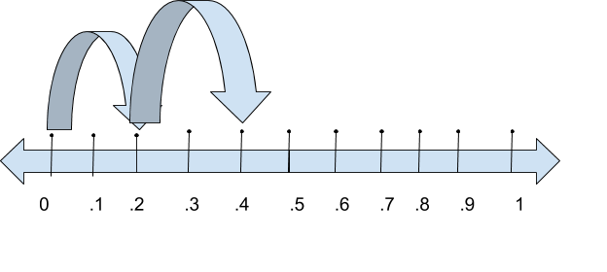

Algorithm

In the divisor (2.4) move the decimal to right of the number. Moving the decimal 1 time out of the number means to multiply by 10. So 2.4 x 10 = 24. Whatever you do to the divisor you have to do to the dividend. Move the decimal to the right one time in the dividend. So 4.8 x 10 = 48. This creates a new division problem that you can solve.

4.8÷ 2.4 = 2 (2 groups of 2.4)

